<https://abhi-fitness.netlify.app/>

3. Gym website project

1.

Amazon

clone project

[https://abhishekchyproject.netlify.app](https://abhishekchyproject.netlify.app/)

[/](https://abhishekchyproject.netlify.app/)

**PROJECT**

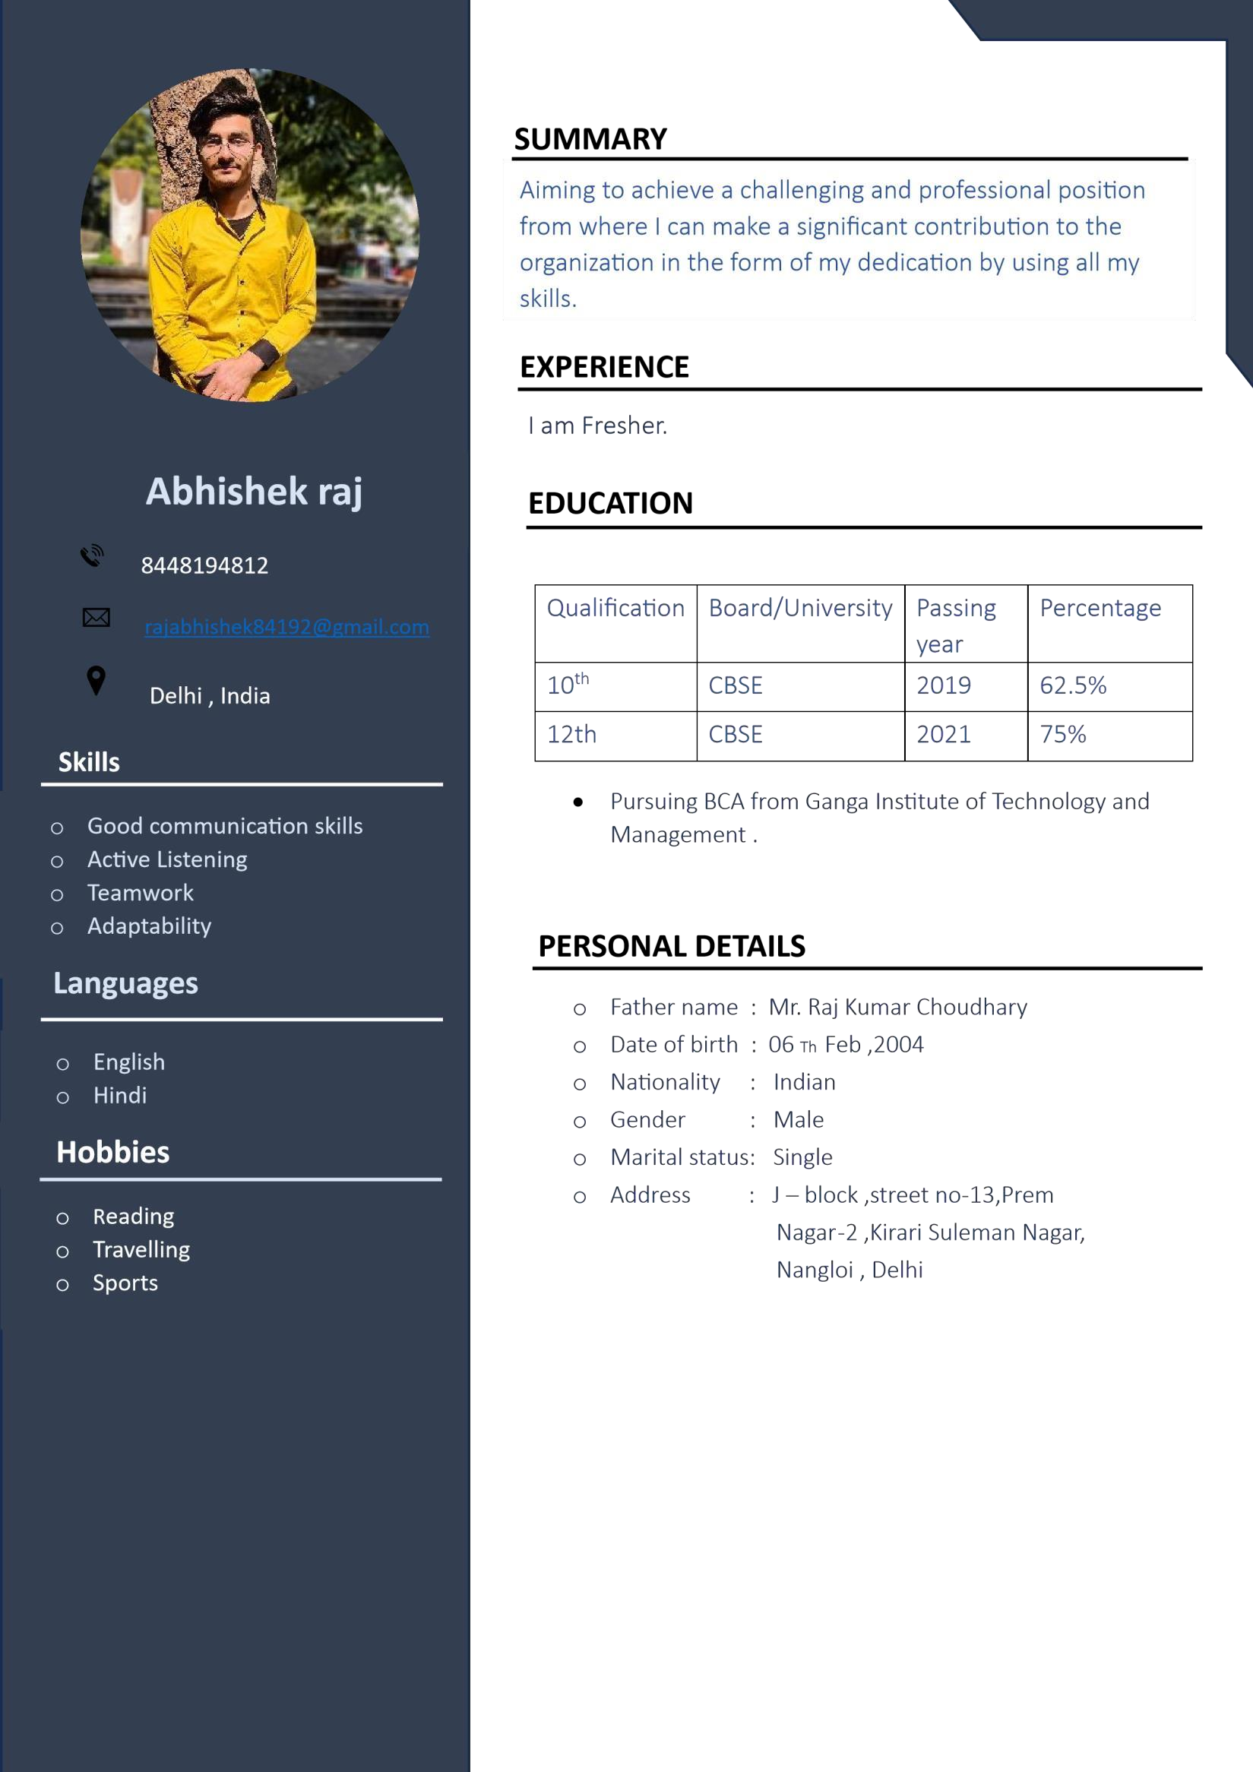

**RESUME**



<https://abhishekchyportfolio.netlify.app/>

2. Portfolio project